Project Report

1. INTRODUCTION

1.1 Overview

Our project is about the India’s Agricultural Crop Analysis. In this project we collected the data about India’s agricultural crop analysis in State, Region and District wise.

1.2 Purpose

With this project we can able to know about the data of Crop production, Production in tonnes in Region wise, Crop Plantation by Area, Major Crops Growth yoy, Season Based Cultivation, Yield by Season.

2. PROBLEM DEFINITION AND DESIGN THINKING

2.1 Empathy Map

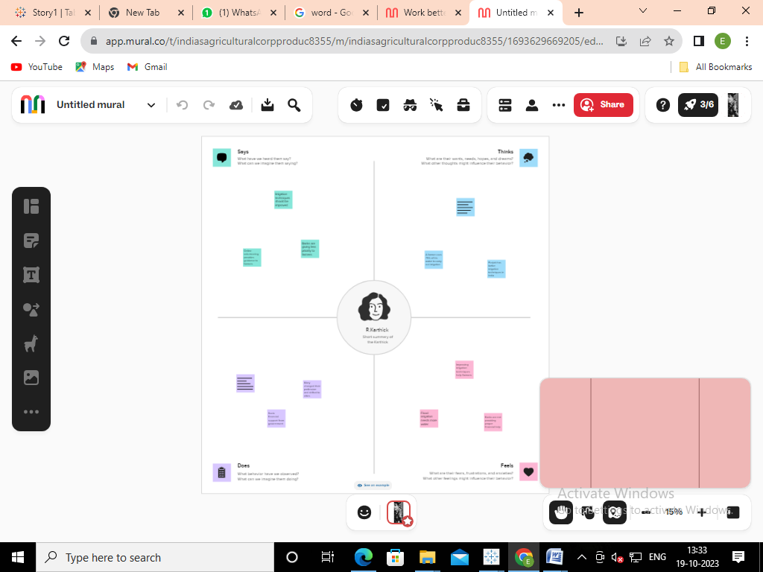

2.2 Ideation and Brainstorming Map

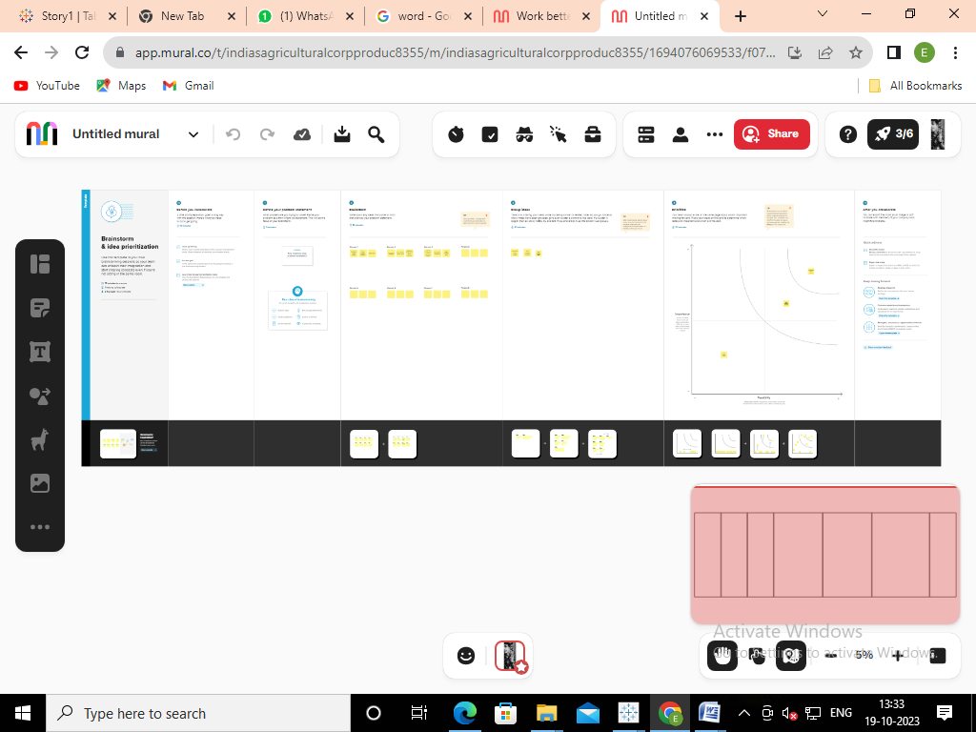

3. RESULT

We find the does, says, thinks and feel

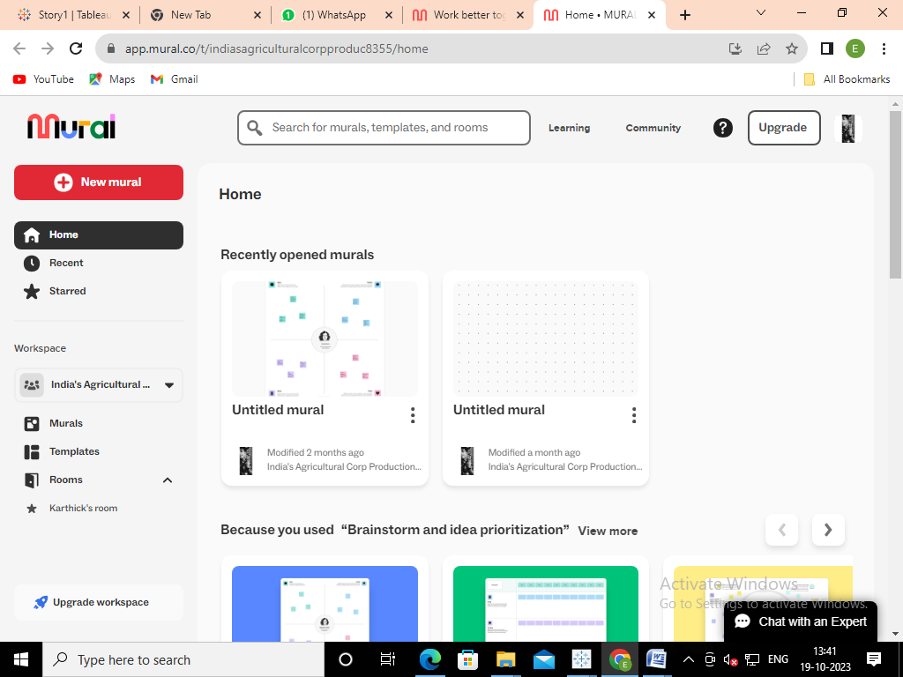

4.ADVANTAGES AND DISADVANTAGES

\* We can find the year wise data with the Graphs

\* We can distinguish the data in Region wise

5. CONCLUSION

We analysed the data about the crop production, major crops in India and also used

Graphs, line charts, bar charts to distinguish the data.